Basic shell scripting
- Basic shell scripting 1 program
Create file suing vi command
Script
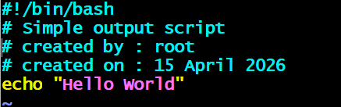
Assigen permission and Execute schript
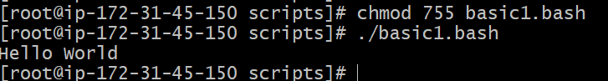

- Basic shell scripting 2 program
Create file using vi command
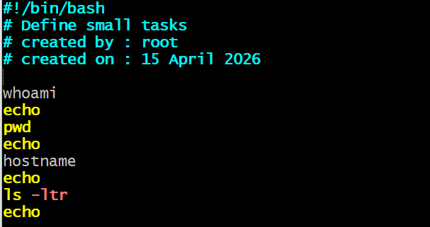
Assign permission and execute file.
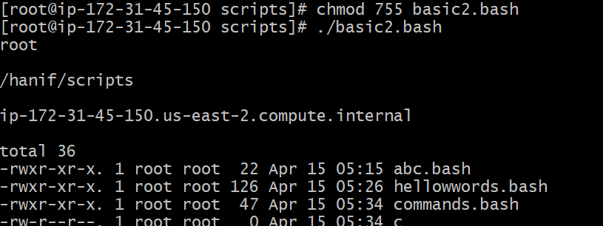
- Basic shell scripting 3 program
Create file using vi command
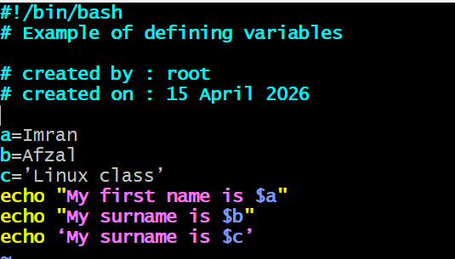
Assign permission and execute file.
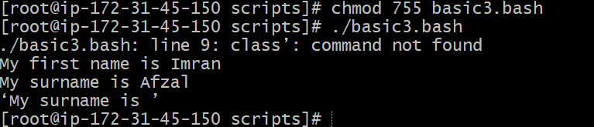

- Basic shell scripting 4 program
Create file using vi command
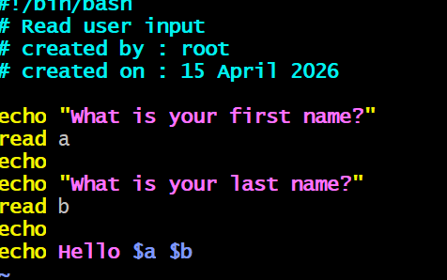
Assign permission and execute file.
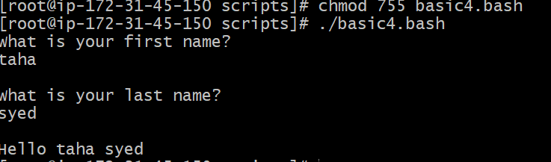
- Basic shell scripting 5 program
Create file using vi command
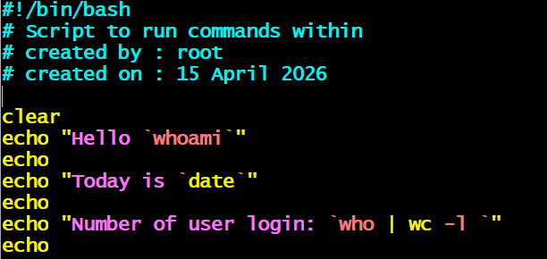
Assign permission and execute file.
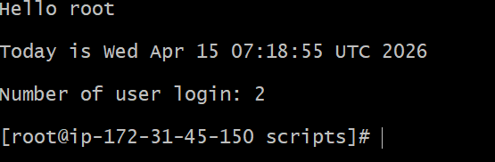
- Basic shell scripting 6 program
Create file using vi command
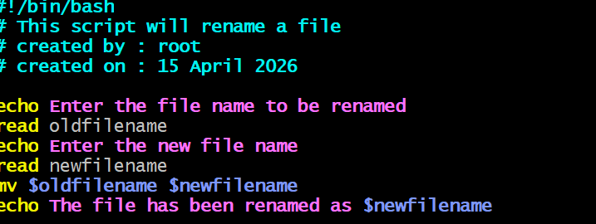
Assign permission and execute file.
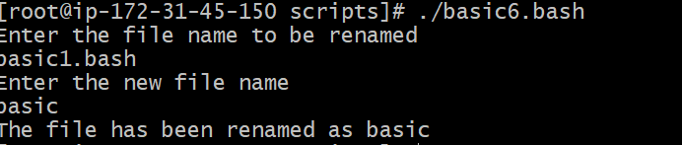
- Do while scripting 1 program
Create file using vi command
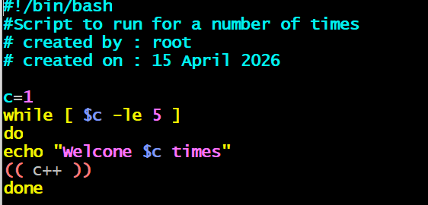
Assign permission and execute file.
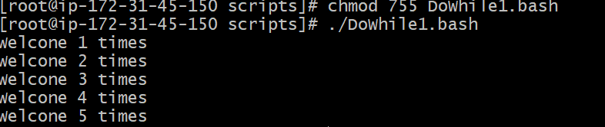
- Do while scripting 2 program
Create file using vi command
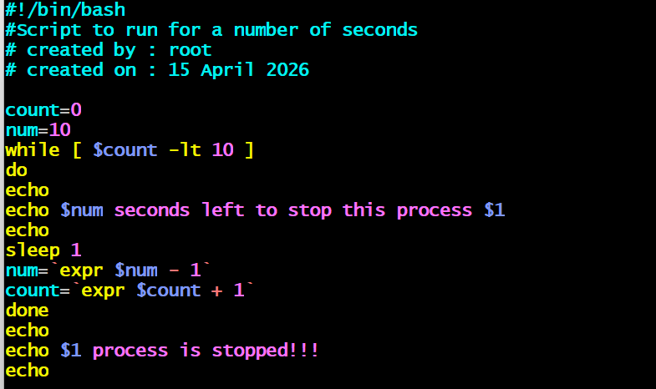
Assign permission and execute file.
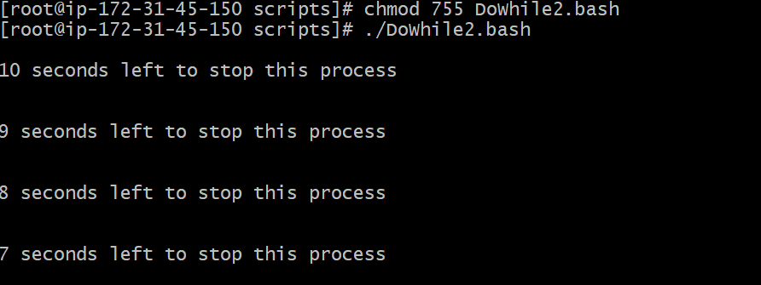
- If Then scripting 1 program
Create file using vi command
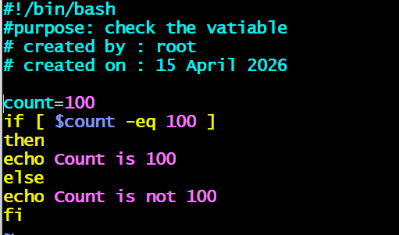
Assign permission and execute file.
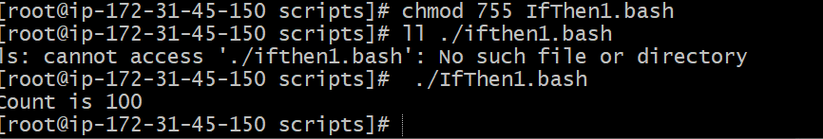
- If Then scripting 2 program
Create file using vi command
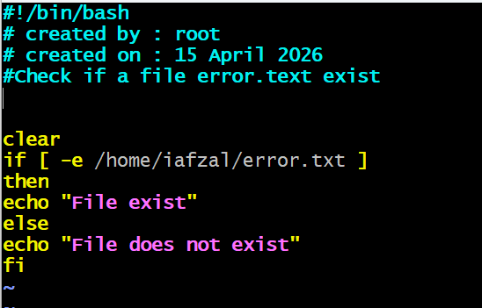
Assign permission and execute file.
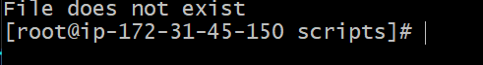
- If Then scripting 3 program
Create file using vi command
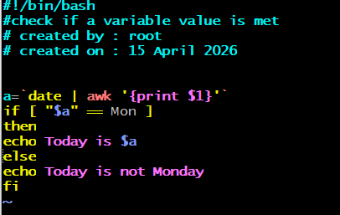
Assign permission and execute file.
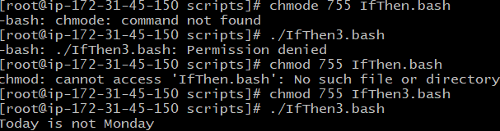
- If Then scripting 4 program
Create file using vi command
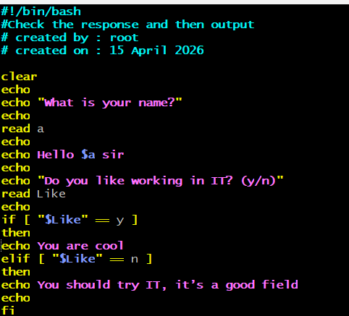
Assign permission and execute file.
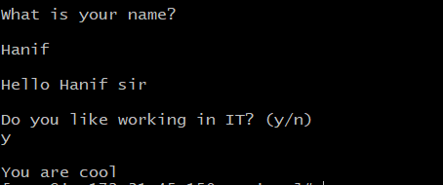
- Case scripting 1 program
Create file using vi command
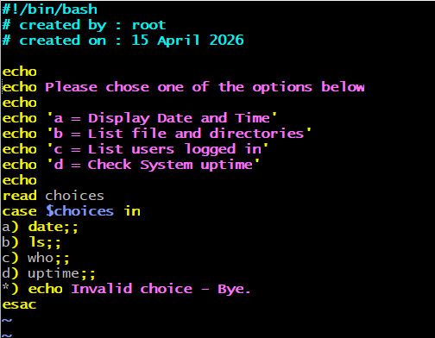
Assign permission and execute file.
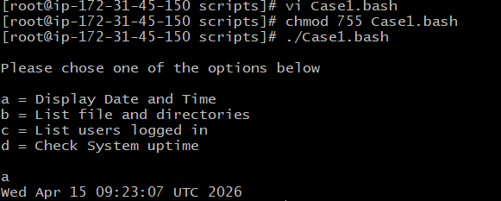
- If Then scripting 2 program
Create file using vi command
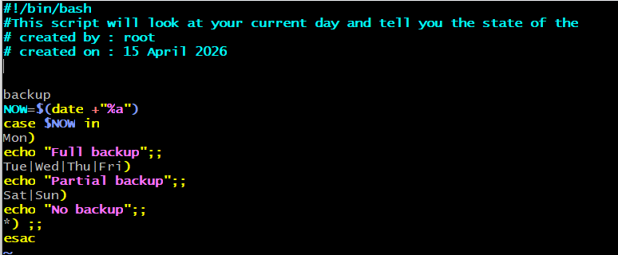
Assign permission and execute file.
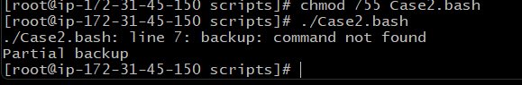
- ForLoop scripting 1 program
Create file using vi command
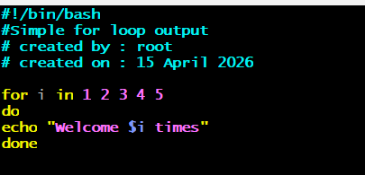
Assign permission and execute file.
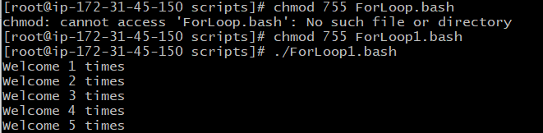
- ForLoop scripting 2 program
Create file using vi command
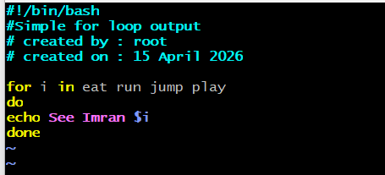
Assign permission and execute file.
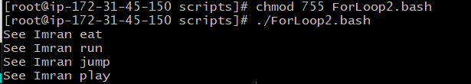
- ForLoop scripting 3 program
Create file using vi command
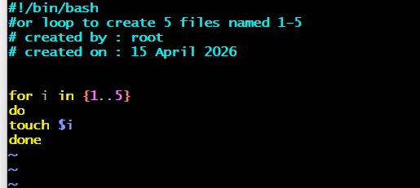
Assign permission and execute file.
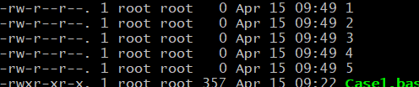
- ForLoop scripting 4 program
Create file using vi command
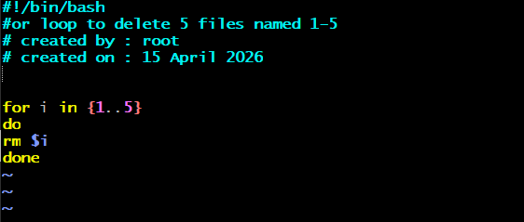
Assign permission and execute file.
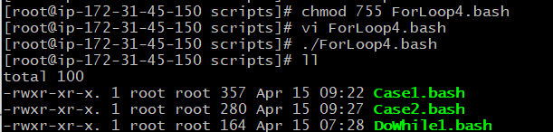
- ForLoop scripting 5 program
Create file using vi command
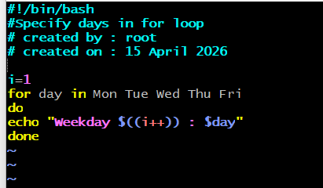
Assign permission and execute file.
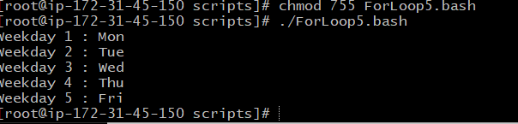
- ForLoop scripting 6 program
Create file using vi command
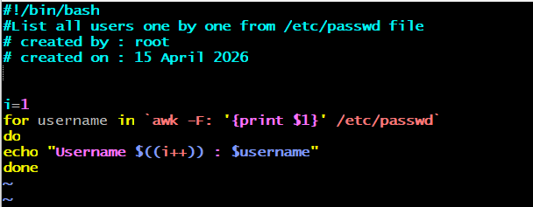
Assign permission and execute file.
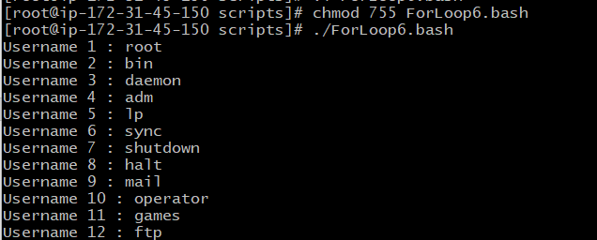
- Create a bash script to check if a directory is available or not.
create file using vi command
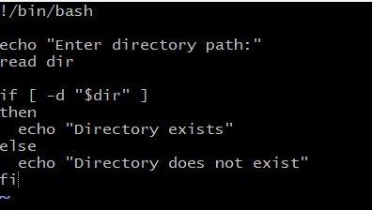
assign permission and execute file
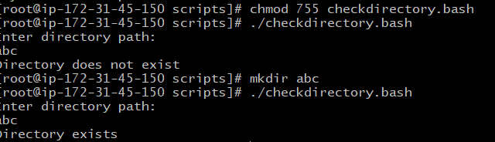
- Create a bash script to create multiple files.
Create file using vi command
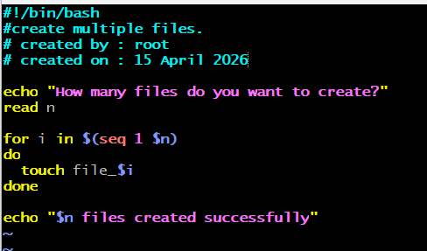
Assign permission and execute file.
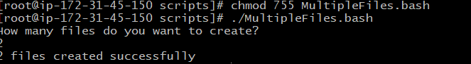
- Create a bash script to take a backup of a directory.
Create file using vi command
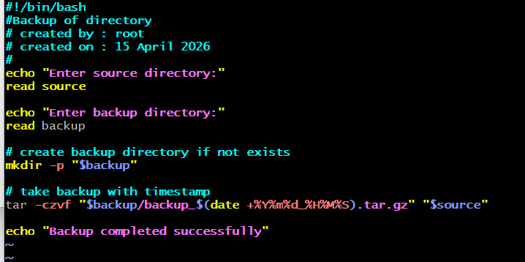Assign permission and execute file.
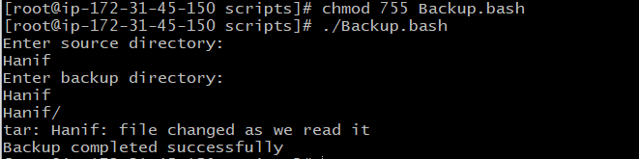
- Create a bash script to install Nginx on an EC2 server
Create file using vi command
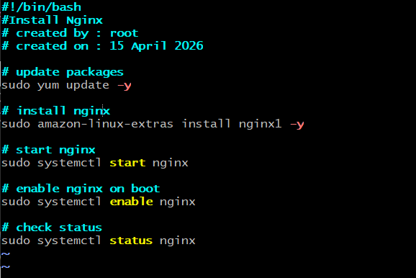

Assign permission and execute file.
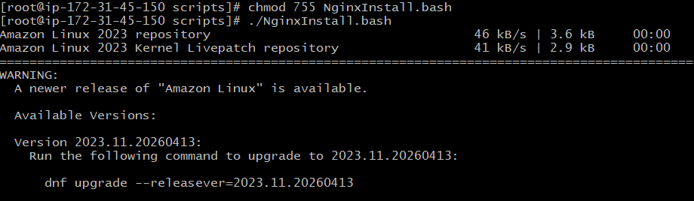
- Create a bash script to install Apache Tomcat on an EC2 server.
Create file using vi command
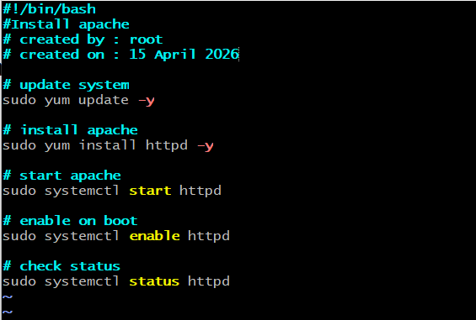
Assign permission and execute file.
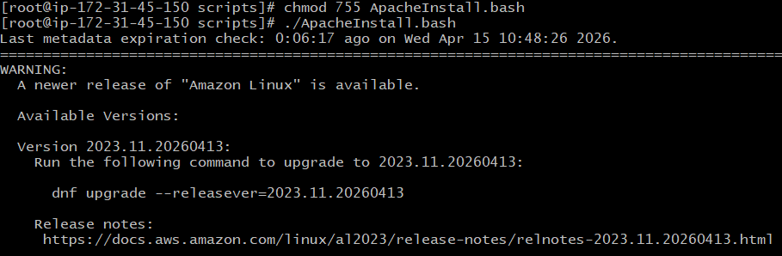
- Create a bash script to check if the Nginx service is running, if not running then script should start the service.
Create file using vi command
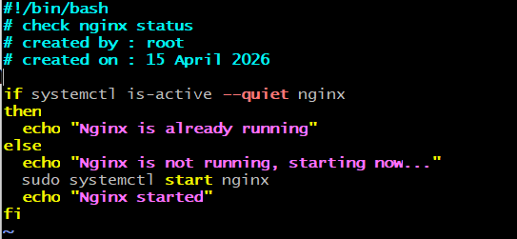
Assign permission and execute file.
- Create a bash script for a calculator.
Create file using vi command
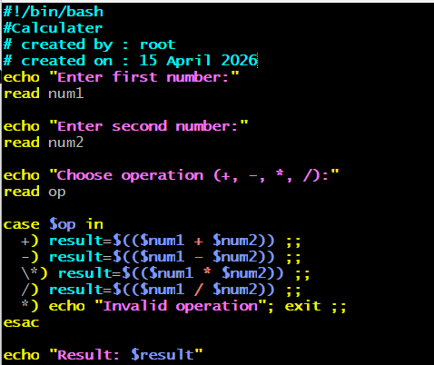
Assign permission and execute file.
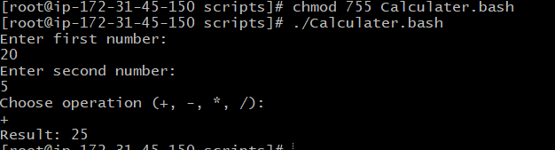
- Create a bash script to check if a directory exists, if not then create a directory.
Create file using vi command
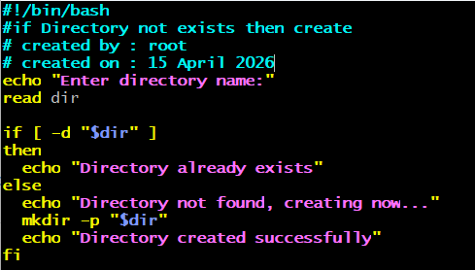
Assign permission and execute file.
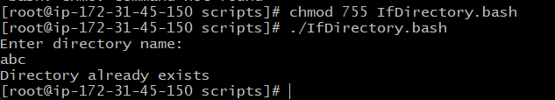
- Create a bash script to delete the last 3 lines of a file.
Create file using vi command
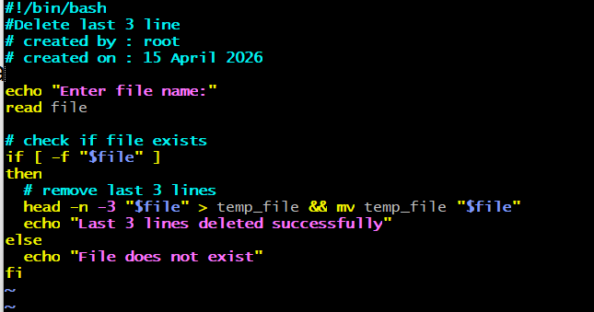
Assign permission and execute file.
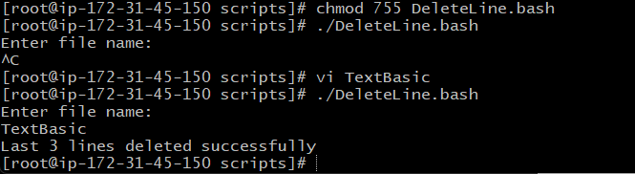
- Bash script to monitor cpu and if it is more than 80% then send email notification.
Frist install mail service, Using command (sudo yum install mailx -y)
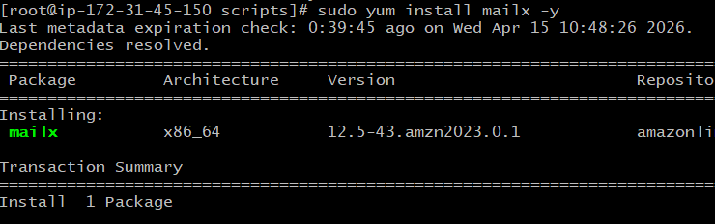
Also installed sudo yum install mailx postfix -y(Amazon server)
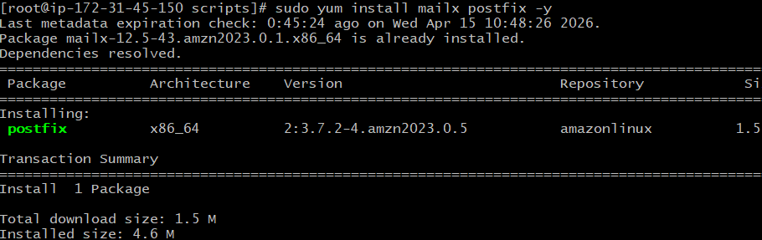
Now start the service postfix
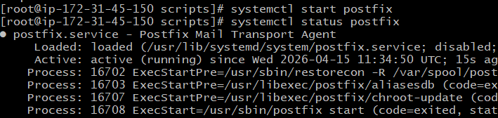
Configure Postfix (sudo vi /etc/postfix/main.cf)
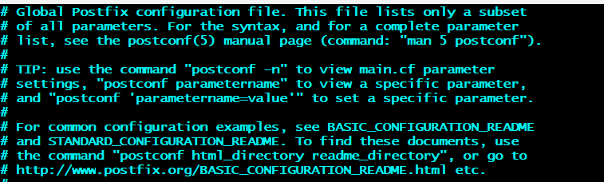
Add below line
relayhost = [smtp.gmail.com]:587
smtp_use_tls = yes
smtp_sasl_auth_enable = yes
smtp_sasl_password_maps = hash:/etc/postfix/sasl_passwd
smtp_sasl_security_options = noanonymous
smtp_tls_CAfile = /etc/ssl/certs/ca-bundle.crt
save file
open this file (sudo vi /etc/postfix/sasl_passwd)
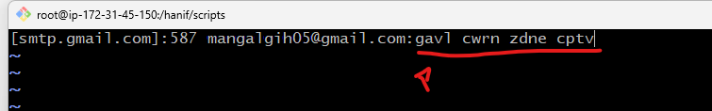
Red Mark is appPasscode created in gmail
After that run below command

sudo chmod 600 /etc/postfix/sasl_passwd
sudo postmap /etc/postfix/sasl_passwd

Now restart postfix
sudo systemctl restart postfix

after that check test mail is sending or not
echo "Test mail from EC2" | mail -s "Test Subject" your_email@gmail.com

Create file using vi command
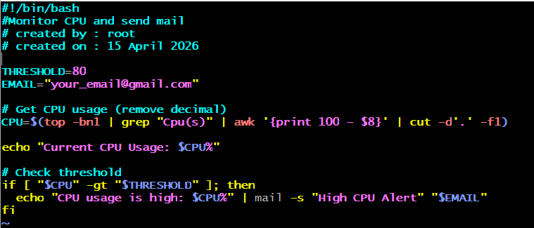
Assign permission and execute file.
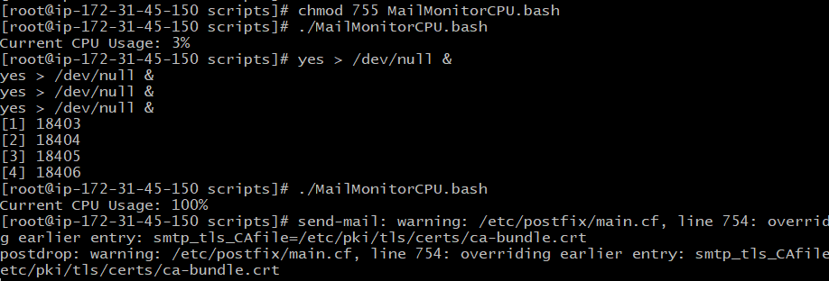
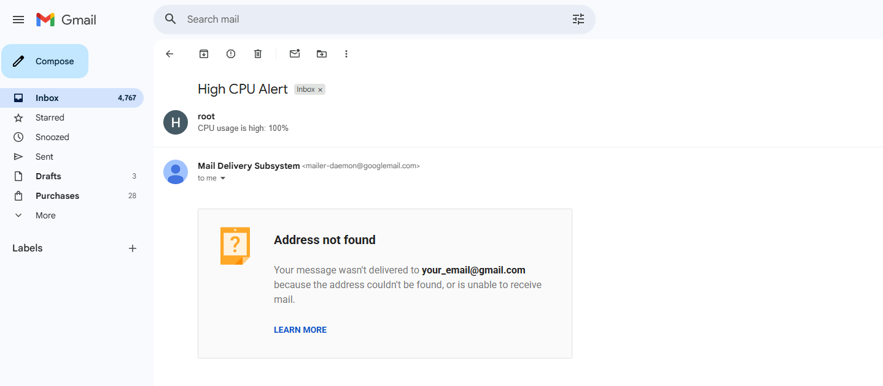
- Bash script to monitor disk space and if it is more than 80% then send email notification.
Create file using vi command
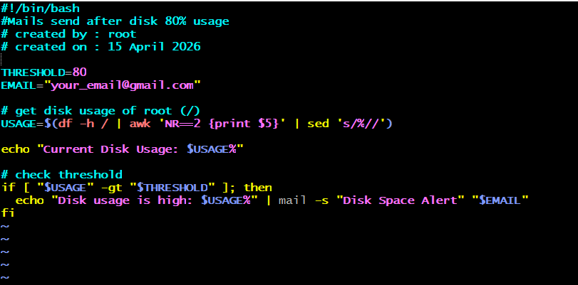
Assign permission and execute file.
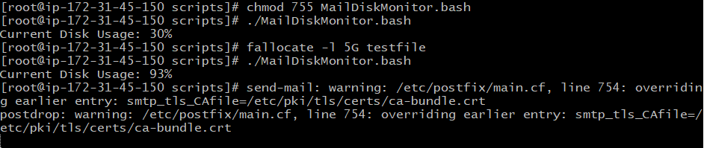
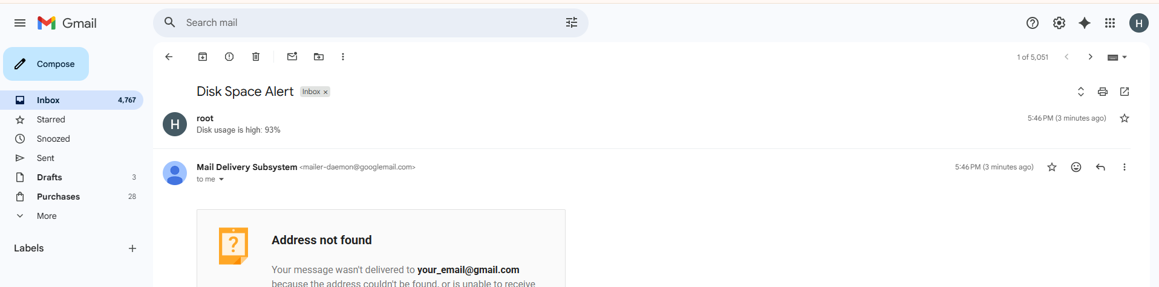
- Bash script to monitor memory and if it is more than 10% then send email notification.
Create file using vi command
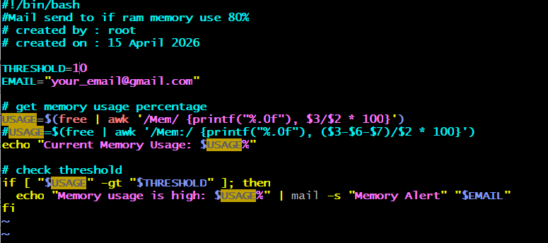

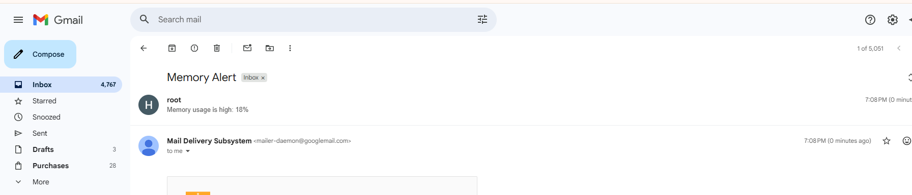

Exercise: Crontab Entries

- April 5th Midnight 5th of Every November, January, June if it is a Thursday.
Create file using vi command
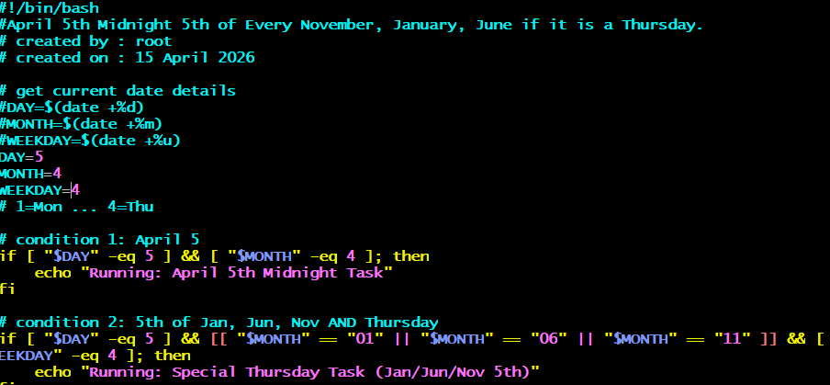
Assign permission and execute file.
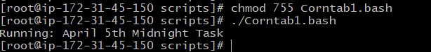

- At 05 and 27th minutes of 9, 10, 11 hours every day 34 minutes of 9th hour on 15th August E very midnight
Create file using vi command
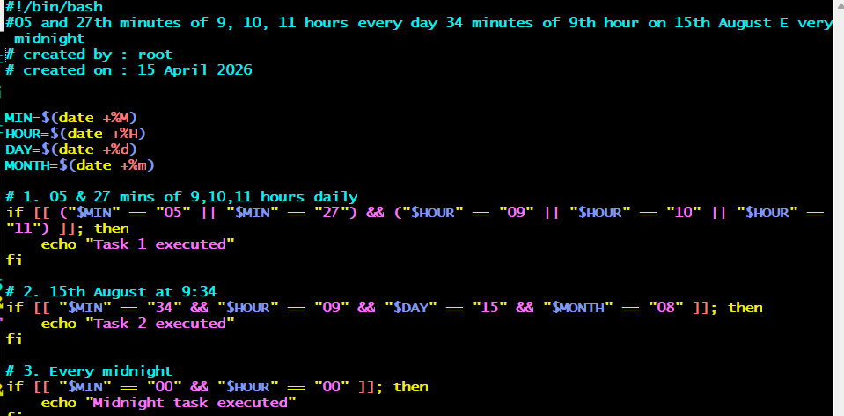
Assign permission and execute file.
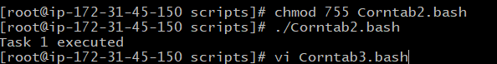

- Every Weekend (Saturday night 11:59 PM) After every reboot.
Create file using vi command
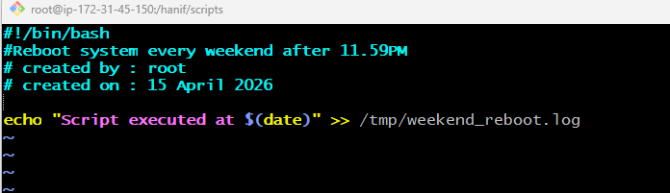
Assign permission and execute file
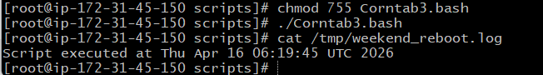

- Share the document and GitHub Repo URL once done for evaluation.
https://github.com/mangalgih05/DevopsCourse.git

- Git init
- Check your current directory file and folder
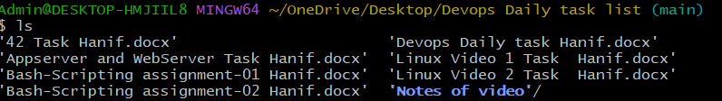
- Add your file in (.git folder which is created your local system ) usint git add Filename command if You want upload all file and Folder then use “git add .” command.
- Now commit your Message using “git commit -m “Your message””
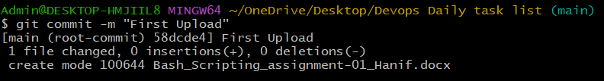
- Now connect to your remote repository using ( git remote add origin Repository address which is https )
- Now connect to main branch using git branch -M main
- Push data in to main branch. Git push origin main command
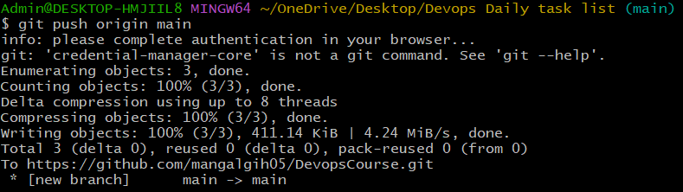
- Check in remote repository
